Intro to Data Communications   
Host Name Resolution

Last Updated: 3/5/2023 5:27 PM Version 2  
Document Prepared for: Professor Lindstrom's Student

# Name Peter Sanford ID 10934984

# Instructions

Answer all questions directly in this document. You will save and upload this completed document as your homework submission.

# Overview

In this lab you will experiment with the hosts file to configure host name resolution and configure a DNS server on your Windows Server.

# Setup

1. Start your VMs, you will use all of your VMs but the routers. To ease the stress on your host machine you will launch them as necessary. Ensure that Your Winserver and Debian VMs are all configured for **VMNet11**, Ensure your pfsense VM has its first network adapter set to NAT and the second network adapter uses **VMNet11**.
2. Start your **pfsense** and **Debian-1** VMs, wait till your pfsense VM is running then start your **WinServer** VM.

# Task 1—using pfsense DNS forwarder

Most firewalls will include a DNS forwarder, a DNS forwarder is a service that will accept DNS queries as if it were a DNS server, it will then forward your query off to another DNS server. By default your pfsense firewall has a DNS forwarder configured, it will accept DNS Queries from the LAN and forward to the DNS server configured by DHCP on the WAN interface.

## Steps

1. Configuring Debian-1
   1. Open your Network settings and configure the following network settings
      1. IP Address Method Manual
      2. IP address: 192.168.1.11
      3. Netmask: 255.255.255.0
      4. Default Gateway: 192.168.1.1
   2. Remove the DNS server address from your network configuration if one exists.  
      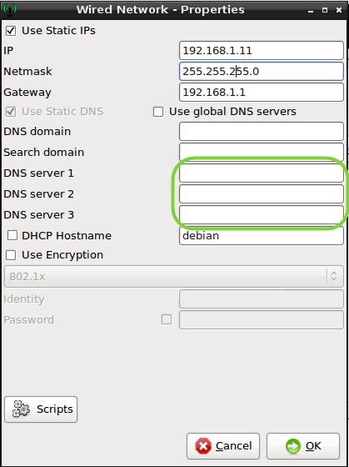
   3. Save your changes.
   4. Clear the global dns configuration file  
      echo ””>/etc/resolv.conf
   5. Ping google.com with the command:   
      ping –c 3 google.com  
      what was the resulting error message? Click here to enter text.
   6. Configure your Debian-1 computer to use the pfsense firewall’s DNS forwarder
      1. Edit the network properties and add a DNS server **192.168.1.1**.  
         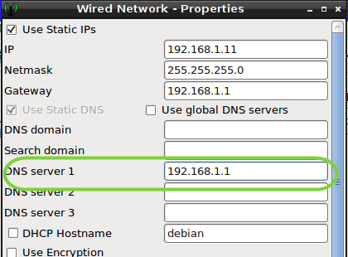
   7. **Save** the settings then disconnect and reconnect the network.
   8. Test the result by attempting to **ping google.com** again.
   9. What IP address was resolved for google? Click here to enter text.
2. Windows
   1. Start you Windows server VM
   2. From your WinServer open PowerShell and enter the command  
      ipconfig /all  
      verify the server has an IP address and is using 192.168.1.1 as its DNS server.
   3. Ping google.com to test name resolution  
      ping google.com
   4. What IP address did the Windows server resolve for google.com? Click here to enter text.
   5. Did it get the same address as your Debian machine? Click here to enter text.

# Task 2—configuring a DNS server

Now you will configure your own DNS server on your Windows Server.

## Steps

1. Before you add the DNS service you should configure a static IP address.
   1. Open the **Network and Sharing center**.
   2. Right click on the network icon in the task bar and select Open Network and Sharing Center  
      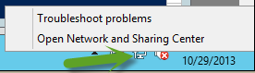
   3. Click **Change adapter settings**.
   4. **Right click** on the **Ethernet** network adapter and select **Properties**.
   5. Open the **IPv4 properties** and enter the following information
      1. IP Address: **192.168.1.10**
      2. Subnet Mask: **255.255.255.0**
      3. Default Gateway: **192.168.1.1**
      4. Preferred DNS Server: **127.0.0.1**
   6. The DNS server address of 127.0.0.1 says that this machine will use itself as a DNS server.
2. Now install the DNS service
3. From a **PowerShell** prompt enter the following command  
   Add-WindowsFeature DNS, RSAT-DNS-Server
4. When the installation completes Ping google  
   ping google.com
5. View the cached results, you can use ipconfig /displaydns or the PowerShell command Get-DNSClientCache, try them both. First enter the command:   
   ipconfig /displaydns  
   now try the PowerShell command, enter

Get-DnsClientCache

1. How many IP addresses were resolved for google.com? Click here to enter text.
2. Which command do you prefer? Click here to enter text.

# Task 3—reconfigure Debian-1

Reconfigure your Debian-1 computer to use the WinServer as its DNS server.

## Steps

1. Change your DNS server address on Debian-1 to 192.168.1.10  
   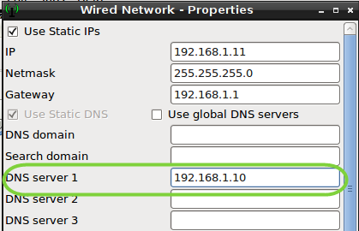
2. Disconnect and reconnect your network.
3. Ping google.com to test name resolution.
4. By default our Linux VMs does not use a client DNS cache like Windows does. Individual programs may cache DNS queries. You can install the nsdc daemon if you would like a DNS client cache in Linux. We will not do that in this lab.
5. Attempt to ping pfsense.esage.us  
   ping pfsense.esage.us.
6. What was the error message? Click here to enter text.

# Task 4—add a DNS zone on your DNS server

Now you will add a new zone to your DNS server to provide name resolutions for the esage.us domain.

## Steps

1. Create a new DNS zone
   1. Start the DNS Management tool
      1. Start Menu
      2. Type DNS then select the DNS tile 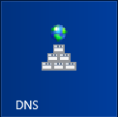 from the search list.
      3. You should see the DNS Manager  
         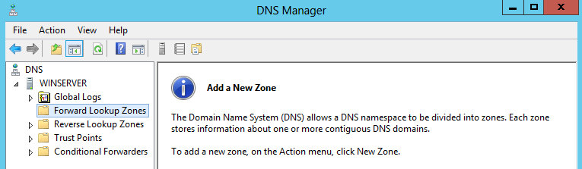
   2. Create a new zone for esage.us. Right-click on the **Forward Lookup Zone** select **New Zone**
   3. Click **Next** on the Welcome page.
   4. Create a **Primary zone**, click **Next**.
   5. Enter **esage.us** for the zone name then click **Next**.
   6. Leave the **Create a new file with this filename** radio button selected, click **Next**.
   7. On the Dynamic Updates select the **Allow both nonsecure and secure dynamic** updates then click **Next**.
   8. Click **Finish**.
2. Adding host records
   1. Now you will add a host record for your pfsense VM
   2. **Select** the **Forward Lookup Zone** **esage.us**.
   3. **Right-click** on the **esage.us** zone and select **New Host(A or AAAA)** record.
   4. Enter the following information
      1. Name: **pfsense**
      2. IP address: **192.168.1.1**
   5. Click the **Add** button.
   6. Click the **Done** button to close the **New host** window.
3. Try to **ping** the host **pfsense.esage.us** from **Debian-1**. This should work properly.
4. Now add an alias for the pfsense VM called firewall.
   1. Right-click on the esage.us zone and select **New Alias (CNAME)** record.
   2. Enter the following information
      1. Alias name: **firewall**
      2. Fully qualified domain name (FQDN) for target host: **pfsense.esage.us**.
   3. Click the **Add** button.
5. **Add** another **alias** for the name **search** that points to the FQDN **bing.com**.
6. Try the names
   1. Open a web browser on either WinServer or Debian-1.
   2. Browse to **search.esage.us**
      1. Where did you end up? Click here to enter text.
   3. Browse to **firewall.esage.us**
      1. After you click through the certificate warning what message did you get? Click here to enter text.
      2. Pfsense is a nice firewall with a lot of protection features. Let’s fix the problem
7. Configure pfsense
   1. Browse to **192.168.1.1** and login as **admin** with the password **Password1**.
   2. Update the hostnames allowed for the firewall
      1. Select **System🡪Advanced**
      2. Find the setting for **Alternate Hostnames**.
      3. Enter both hostnames (separated by spaces) **firewall.esage.us pfsense.esage.us**.
      4. Click **Save** to save the settings.
   3. Configure DCHP to use our DNS server.
      1. Select **Services🡪DHCP Server.**
      2. Locate the **DNS servers** option enter the IP address of the WinServer **192.168.1.10**.
      3. Click **Save** to save the settings.
8. Reconfiguring our network
   1. Start Debian-2 and Debian-3.
   2. Configure/verify the following Network settings.

|  |  |  |  |  |  |
| --- | --- | --- | --- | --- | --- |
| VM | Network | IP address | Netmask | Gateway | DNS Sever 1 |
| Debain2 | VMNet11 | 192.168.1.12 | 255.255.255.0 | 192.168.1.1 | 192.168.1.10 |
| Debian3 | VMNet11 | 192.168.1.13 | 255.255.255.0 | 192.168.1.1 | 192.168.1.10 |

* 1. Disconnect and reconnect the
  2. Verify and test your configurations by pinging firewall.esage.us.

1. Add records for your Debian servers on the DNS server. Create the following Host records in the esage.us zone.

|  |  |
| --- | --- |
| **Hostname** | **IP address** |
| d1 | 192.168.1.11 |
| d2 | 192.168.1.12 |
| d3 | 192.168.1.13 |

1. Test the new hostnames by pinging them from your winserver.

# Task 5—Dynamic DNS updates.

As you have discovered it is a bit of a pain to configure host records for each server on your network. Modern DNS servers allow for dynamic updates. A dynamic update is when the client computer tells the DNS sever what its hostname and IP address are, so the DNS server can automatically add a record for that server. You may have noticed that there is no host record for the WinServer, you will now enable dynamic updates on the server. In a fully enterprise environment the DHCP server would typically update the DNS server, since it is beyond the scope of this class to show how do that we you will just configure the client to update the server itself.

## Steps

1. Open your IPv4 Settings on your WinServer.
2. Click the **Advanced** button.
3. Select the **DNS** tab.
4. Toward the bottom of the windows configure the following parameters:
   1. DNS suffix for this connection: **esage.us**
   2. Check Register this connection’s address in DNS
   3. Check Use this connection’s DNS suffix in DNS registration.
5. Your configuration should look like this  
   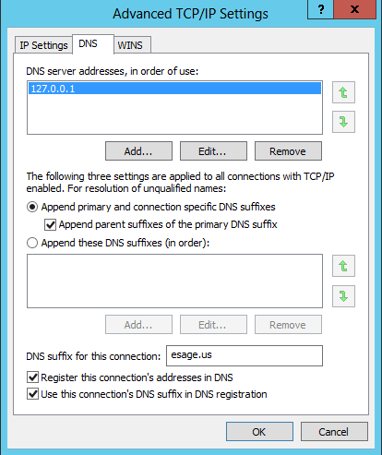
6. Click **OK** until all your network settings are closed.
7. Force the DNS client to update the DNS server with the command:  
   ipconfig /registerdns
8. Now view the esage.us zone. You may need to refresh the data, you should see a host record for the name Winserver.
9. Try the new name out with a ping, it should work.

# Task 6-host names and the hosts file

Both Linux and windows use a hosts file to allow custom name resolutions. Now you will add an entry in the hosts file on both platforms.

## Steps

1. Hosts file on Linux.
   1. Let’s view the contents of your hosts file, on **Debian-1**, enter the command   
      cat /etc/hosts
   2. The hosts file contains name resolutions that you can customize yourself.
   3. There are two sections in the file one for IPv4 and 1 for IPv6. Record the IPv4 Address entries here (add rows if necessary):

|  |  |
| --- | --- |
| IP Address | Hostname |
| Click here to enter text. | Click here to enter text. |

* 1. Now you will add an entry called “search” to the host file that will point to google. First you need to know what Google’s IP address is. Use nslookup to find goodle’s iP address(es)  
     nslookup google.com  
     Record an IP address here. Click here to enter text.
  2. Now enter the following command to open the hosts file in a nice editor:  
     leafpad /etc/hosts
  3. This will open the hosts file in a graphical text editor.
  4. Add the following line:  
     **<google’s IPAddress><tab>search**
     + 1. So if google’s IP address was 74.125.225.160 the command line would be  
          **74.125.225.160 search**
  5. **Quit** leafpad and **save** the changes.
  6. Open a web browser and browse to [**http://search**](http://search)

1. Hosts on windows
   1. From your windows server, open the file C:/windows/System32/Drivers/etc/hosts with notepad
   2. Notice the file is quite similar in format to Linux. Lines that start with a # are comment lines
   3. What hosts are defined? Click here to enter text.
   4. Add a line with Google’s IP address and the name **find**
   5. Save and close the file.
   6. Open Internet Explorer and browse to <http://find> you should see google.

# Task 7—viewing the DNS file for esage.us

Finally you will view the configuration file for the Window’s DNS server.

## Steps

1. From your windows server, open the file C:\Windows\System32\dns\esage.us.dns with notepad.
2. You must then choose a method to upload this file to canvas some ideas
   1. Copy the file to the desktop
   2. then select it and ctrl-c to copy to windows clipboard then ctrl-v paste to the host machine
   3. then Email the file to yourself
   4. then Login to canvas and submit form Windows server hosted VM
   5. select all the text in the file and copy that to windows clipboard, open a text editor such as notepad on the host machine and paste the text there
   6. Share the file with the host machine using vmware tools
   7. Copy the file up to a storage drive such as onedrive, google drive, etc.
   8. Copy and paste the file into an online text editor <https://www.google.com/search?q=free+online+text+editor>
   9. Any other method you can think of that works

# Wrap-up

Shutdown you VMs and call it a day.

# Deliverable

From your windows server computer, upload the file C:\Windows\System32\dns\esage.us.dns as well as this file to canvas.

Upload this document to canvas.